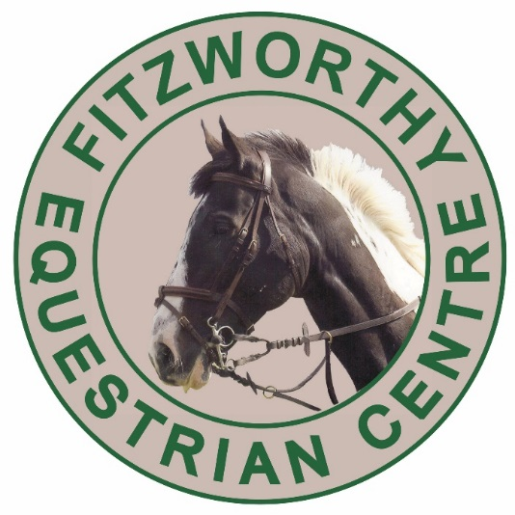
01752 837000

South West Pony Association Championships Qualifying Rules
This show is a qualifier for the South West Pony Association Championships
to be held in September 2019
at The David Broome Event Centre, Crick, Gwent..

To qualify for the Championships:
1. Enter one of the qualifying classes.
2. Be one of the two highest placed exhibits not already qualified within the first four and receive
a qualification card signed in the ring.
3. Complete the entry form on the qualification card.
4. Return the card to together with any registration fees due within 14 days of this show.

HORSE SHOW RULES 1. The organisers at FEC will take all reasonable precautions to ensure the health and safety of everyone present. For these measures to be effective, everyone present must take all reasonable precautions to avoid and prevent accidents occurring and must obey the instructions of the organisers, officials and stewards. 2. The organisers of the Fitzworthy Show hereby give notice that they will accept no liability for injury to a person or any animal or for any loss or damage whatsoever suffered by any competitor, exhibitor or exhibit in any horse jumping or showing competition or event. All such competitors take part at their own risk and before entering should inspect all course constructions of jumps or obstacles and ground conditions to ensure and satisfy themselves that they are safe. 3. Verbal or physical abuse toward any person or animal will not be tolerated. This includes the misuse of whips and spurs as judged by the Show secretary or judge. 4. It is a condition of entry that all persons whilst mounted wear fastened hard hats and purpose designed footwear conforming to British Safety Standards.
5. It is strongly recommended that leaders wear hard hats and purpose designed footwear conforming to British Safety Standards. 6. Jackets to be worn in the show jumping rings unless permission from the judges is obtained. 7. No horse or pony under 4 years may be shown under saddle.
First Aiders will be on site throughout the event.

£7.00 per class
In Hand Classes Starting 9 am prompt
1) Best 1, 2,3 Year old. 2) Show/Riding Pony Not to exceed 148cm. 3) Show Hunter Not to exceed 153cm 4) Hunters Exceeding 148cms. Riders to have attained their 16th birthday before January 1st in the current year. 5) Hacks and Riding Horse Hacks not to exceed 160cms Riding horses to exceed 148cm 6) Pony club, Riding Club or competition type 7) Traditional Cob 8) Pure, Part Bred and Anglo Arab 9) Mountain and Moorland Ponies must be registered with their respective Pure Breed Society Stud Books. Classes may split into Ages and or Breeds. 10) World Breeds Horse or Pony (Excluding British Native Breeds, M&M Part Breds, Pure, Part Bred & Anglo Arabs) 11) Coloured Horse or Pony To include Skewbald, Piebald, Appaloosa, Palomino and Dun. 12) Veteran Horse/Pony 15 yrs and over
In Hand CHAMPIONSHIP ALL 1st and 2nd place winners eligible
Ridden Classes Starting 1.30pm prompt
12) Open Lead Rein Not to exceed 122cms. Riders not to have attained their 8th birthday before 1st January in the current year. 13) Open First Ridden Not to exceed 122cms. Riders not to have attained their 10th birthday before 1st January in the current year. 14) Show/Riding Pony Riders must be correct age for height of pony they ride:- n/e 128cms, Riders not to have attained their 13th birthday before 1st January in the current year. ex 128cms - n/e 138cms, Riders not to have attained their 15th birthday before 1st January in the current year. ex 138cms - n/e 148cms, Riders not to have attained their 17th birthday before 1st January in the current year 15) Show Hunter Mare or Gelding. Not to exceed 153cms. Riders must be correct age for height of animal they ride:- n/e 122cms, Rider not to have attained their 11th birthday before 1st January in the current year. ex 122cms - n/e 133cms, Riders not to have attained their 14th birthday before 1st January in the current year. ex 133cms - n/e 143cms, Riders not to have attained their 17th birthday before 1st January in the current year. ex 143cms - n/e 153cms, Riders not to have attained their 20th birthday before 1st January in the current year 16) Hunters Ridden Exceeding 148cm 17) Hacks and Riding Horse Hacks not to exceed 160cms Riding horses to exceed 148cm 18) Traditional Cob 19) Show Cob Exceeding 148cm. Riders to have attained 15th birthday by 1st January in the current year. 20) Pure, Part Bred and Anglo Arab Ridden 21) Mountain and Moorland Stallion, Mare or Gelding. To be registered with their respective Pure Breed Society Stud Books. Riders any age. (see rules for Ridden Stallions) Classes may be split into Breed sections. 22) World Breeds Horse or Pony. (Excluding British Native Breeds, M&M Part Breds, Pure, Part Bred & Anglo Arabs) 4 years and over 23) Racehorse to Riding horse Horse/Pony 4 years and over 24) Coloured Horse or Pony To include Skewbald, Piebald, Appaloosa, Palomino and Dun. 25) Veteran Horse/Pony 15 yrs and over

Ridden Championship all 1st and 2nd place winners eligible
Supreme Championship – All in hand and Ridden Champions are eligible

